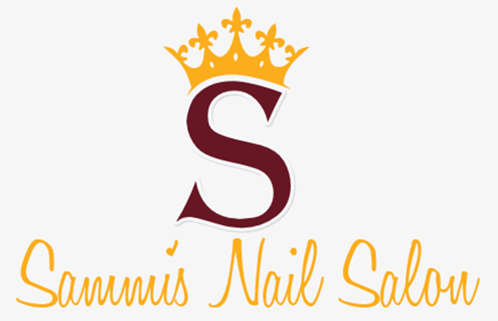The logo for my business is the name with a large S in the top middle and a crown in top. The different business strategies I found were Business Cards, Billboard, Flyers, Website, and Newspaper Ads, the Business Cards cost $7, 4897.50 a month for 250 of them, the billboard costs $450 a month to keep up, the flyer costs $0.02 for each one for 1,000 of them per month which is $20.00, the website costs $12 per month, and the Newspaper Ads cost $140 per month. The three strategies I chose for my business was the Business cards, Billboard, and the Flyers

The ROI for the business cards is 575 %, the ROI for the billboard is 663%, and the ROI for the flyers is 668%. The overall costs for my strategies is $7,497.50 a month and $95,610 a year

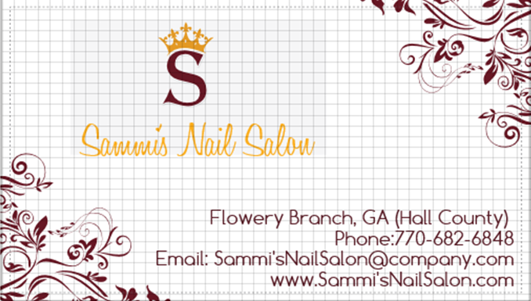
The monthly costs for my strategies will affect my business very little because I will still have money to buy my supplies and pay my employees.
Business Card

